Instructions for Work Context Questionnaire

Instructions

In this questionnaire you will be asked about your working conditions. These questions are about your work setting and its possible hazards, the pace of your work, and your dealings with other people.

Read each question carefully and look closely at answer choices after each question. Put an X through the number for the answer that best describes your current job.

For example:

How many hours do you work in a typical week?
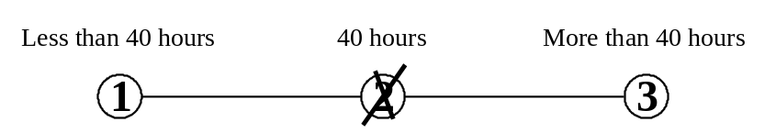

Mark your answer by putting an X through the number that represents your answer.
Do not mark on the line between the numbers.

1. How often does your current job require face-to-face discussions with individuals and within teams?

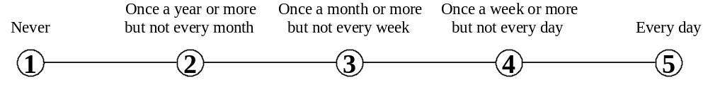

2. How frequently does your current job require public speaking (one speaker with an audience)?

3. How frequently does your current job require telephone conversation?

4. How frequently does your current job require electronic mail?

5. How frequently does your current job require written letters and memos?

6. How much contact with others (by telephone, face-to-face, or otherwise) is required to perform your current job?

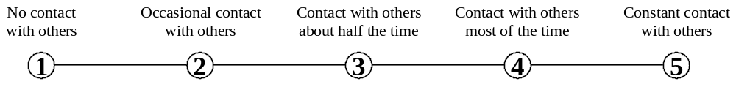

7. How important are interactions that require you to work with or contribute to a work group or team to perform your current job?

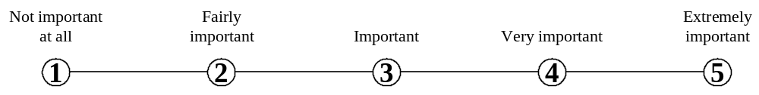

8. In your current job, how important are interactions that require you to deal with external customers (as in retail sales) or the public in general (as in police work)?

9. In your current job, how important are interactions that require you to coordinate or lead others in accomplishing work activities (not as a supervisor or team leader)?

10. How responsible are you for the health and safety of other workers on your current job?

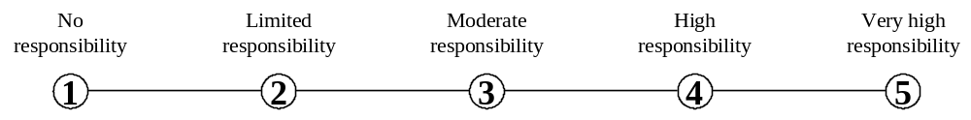

11. How responsible are you for work outcomes and results of other workers on your current job?

12. How often are conflict situations a part of your current job?

13. How often is dealing with unpleasant, angry, or discourteous people a part of your current job?

14. How often is dealing with violent or physically aggressive people a part of your current job?

15. How often does your current job require you to work indoors in an environmentally controlled environment (like a warehouse with air conditioning)?

- How often does your current job require you to work in an environment that is not environmentally controlled (like a warehouse without air conditioning)?

17. How often does your current job require you to work outdoors, exposed to all weather conditions?

18. How often does your current job require you to work outdoors, under cover (like in an open shed)?

19. How often does your current job require you to work in an open vehicle or operating equipment (like a tractor)?

20. How often does your current job require you to work in a closed vehicle or operate enclosed equipment (like a car)?

21. How physically close to other people are you when you perform your current job?
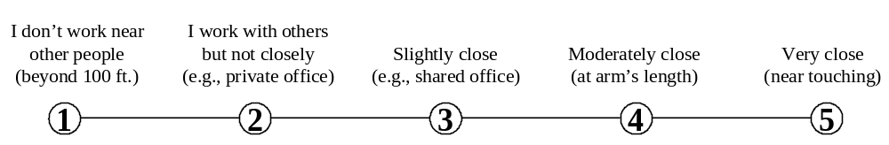

22. In your current job, how often are you exposed to sounds and noise levels that are distracting and uncomfortable?

23. In your current job, how often are you exposed to very hot (above 90° F) or very cold (under 32° F) temperatures?

24. In your current job, how often are you exposed to extremely bright or inadequate lighting conditions?

25. In your current job, how often are you exposed to contaminants (such as pollutants, gases, dust, or odors)?

26. In your current job, how often are you exposed to cramped work space that requires getting into awkward positions?

27. In your current job, how often are you exposed to whole body vibration (like operating a jackhammer or earth moving equipment)?

28. How often does your current job require that you be exposed to radiation?

29. How often does your current job require that you be exposed to diseases or infection? This can happen with workers in patient care, some laboratory work, sanitation control, etc.

30. How often does your current job require that you be exposed to high places? This can happen for workers who work on poles, scaffolding, catwalks, or ladders longer than 8 feet in length.

31. How often does your current job require that you be exposed to hazardous conditions? This can happen when working with high voltage electricity, flammable material, explosives, or chemicals. Do not include working with hazardous equipment.

32. How often does your current job require that you be exposed to hazardous equipment? This includes working with saws, close to machinery with exposed moving parts, or working near vehicular traffic (but not including driving a vehicle).

33. How often does your current job require that you be exposed to minor burns, cuts, bites, or stings?

34. How much time in your current job do you spend sitting?

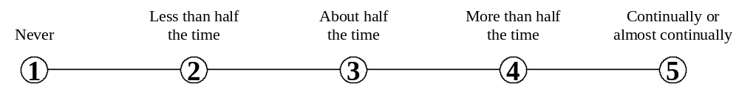

35. How much time in your current job do you spend standing?

36. How much time in your current job do you spend climbing ladders, scaffolds, poles, etc.?

37. How much time in your current job do you spend walking or running?

38. How much time in your current job do you spend kneeling, crouching, stooping, or crawling?

39. How much time in your current job do you spend keeping or regaining your balance?

40. How much time in your current job do you spend using your hands to handle, control, or feel objects, tools, or controls?

41. How much time in your current job do you spend bending or twisting your body?

42. How much time in your current job do you spend making repetitive motions?

43. In your current job, how often do you wear common protective or safety equipment such as safety shoes, glasses, gloves, hearing protection, hard hats, or life jackets?

44. In your current job, how often do you wear specialized protective or safety equipment, such as breathing apparatus, safety harness, full protection suits, or radiation protection?

45. How serious a mistake can you make on your current job (one you can’t easily correct)?
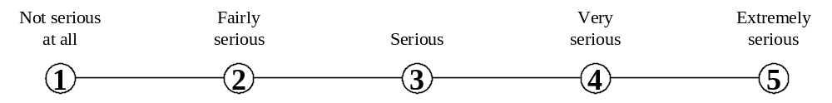

46. In your current job, what results do your decisions usually have on other people or the image or reputation or financial resources of your employer?

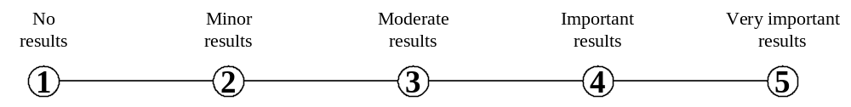

47. In your current job, how often do your decisions affect other people or the image or reputation or financial resources of your employer?

48. In your current job, how much freedom do you have to make decisions without supervision?

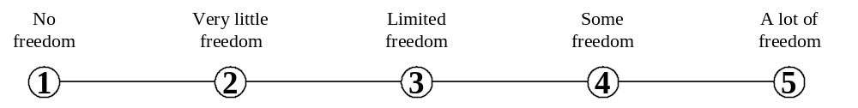

49. How automated is your current job?

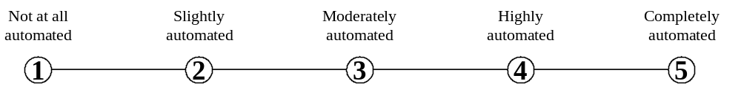

50. How important to your current job is being very exact or highly accurate?

51. How important to your current job are continuous, repetitious physical activities (like key entry) or mental activities (like checking entries in a ledger)?

52. How much freedom do you have to determine the tasks, priorities, or goals of your current job?

53. How competitive is your current job?

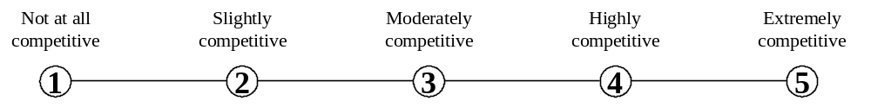

54. How often does your current job require you to meet strict deadlines?

55. How important to your current job is keeping a pace set by machinery or equipment?

56. How regular is your work schedule on your current job?

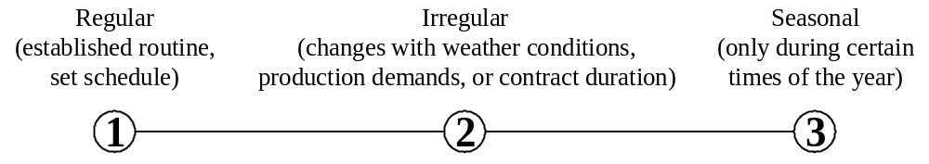

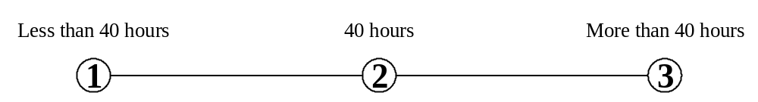57. How many hours do you work in a typical week on your current job?

